**Test Case 7**

**System:** Bench

**Description:** Test for the showing and managing of the chat history.

**Severity:** 3

**Instructions**

**Test 1**

1. Start the Bench application.
2. Click the button “Login” on the navigation bar.
3. Enter the email “user1@gmail.com” into the text field labeled “Email address”.
4. Enter the password “12345678” into the field labeled “Password”.
5. Click the button “Login” below the field.
6. After the screen has loaded, click on the button “Chat” on the navigation bar.
7. Click on any of the existing chat panels listed on the left sidebar.

**Expected Result:** the current user should be able to view the chat history in the chat room between the current user and the selected user.

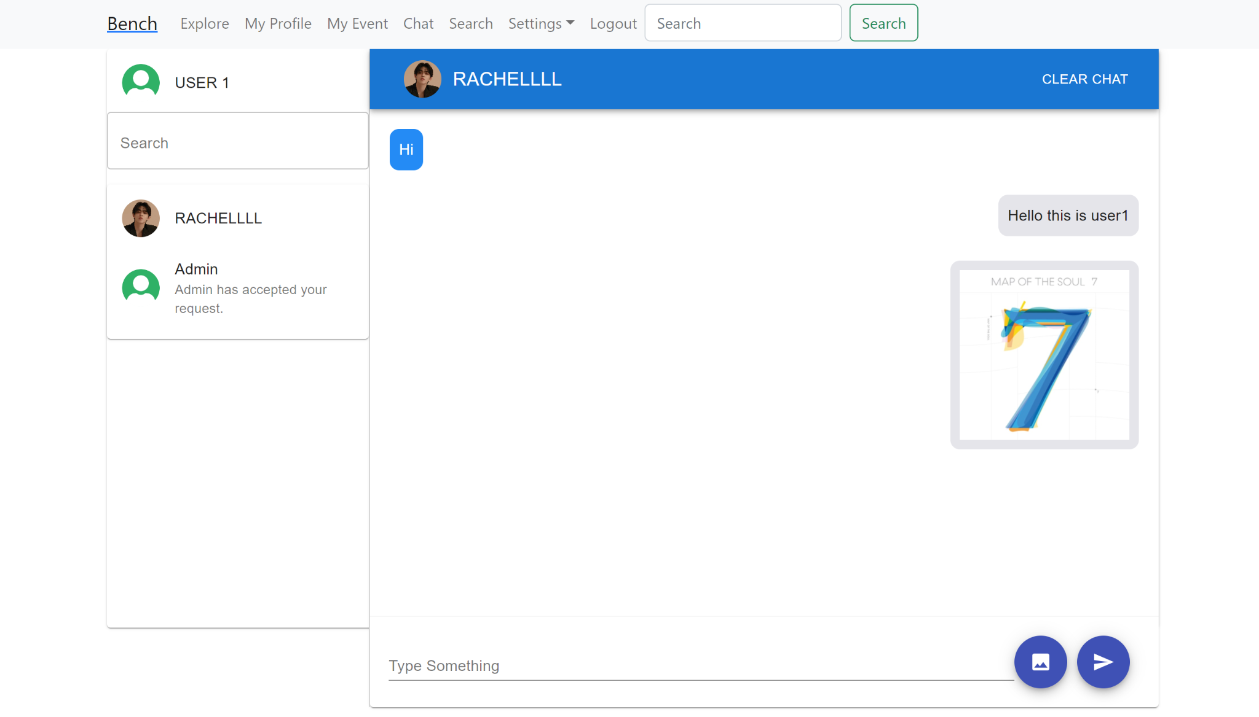

**Test 2**

1. Start the Bench application.
2. Click the button “Login” on the navigation bar.
3. Enter the email “user1@gmail.com” into the text field labeled “Email address”.
4. Enter the password “12345678” into the field labeled “Password”.
5. Click the button “Login” below the field.
6. After the screen has loaded, click on the button “Chat” on the navigation bar.
7. Click on any of the existing chat panels listed on the left sidebar.
8. Look at each message in the chat history.

**Expected Result:** The message sent by the other user should appear on the left side of the chat room, while the messages sent by the current user should appear on the right side of the chat room, so it’s easy to identify which user has sent the specific message.

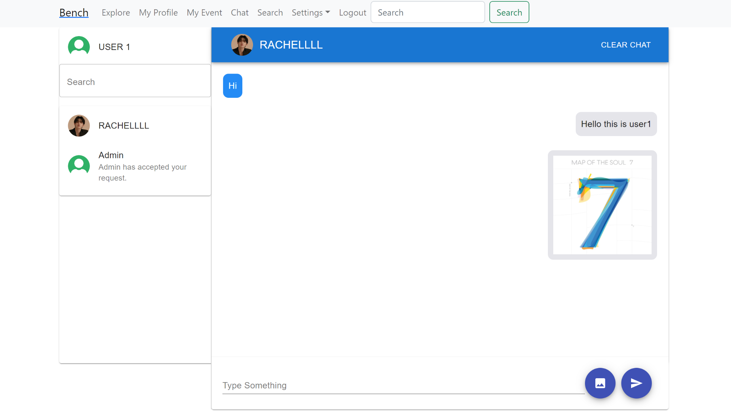

**Test 3**

1. Start the Bench application.
2. Click the button “Login” on the navigation bar.
3. Enter the email “user1@gmail.com” into the text field labeled “Email address”.
4. Enter the password “12345678” into the field labeled “Password”.
5. Click the button “Login” below the field.
6. After the screen has loaded, click on the button “Chat” on the navigation bar.
7. Click on any of the existing chat panels listed on the left sidebar.
8. There should exist a button labeled with “CLEAR CHAT” on the top right corner of each chat room.
9. Click on the button “CLEAR CHAT”.

**Expected Result:** All the messages and images in the chat history should disappear in the chat room between the two users.

